MEMORANDUM
To: | North American Distributor Management
From: | Eric Stieber, Sales Operations Manager
Date: | October 8, 2018
Re : | 2018 – New Handle Standoff - Wolf E Series Contemporary Built-In Ovens

This memo will provide you with information regarding a running change made to the handle standoffs installed 30” E Series Contemporary Built-In Ovens shipping from the factory starting August 2018. This change is considered low impact due to the subtlety of the change and the standoff location being affected.

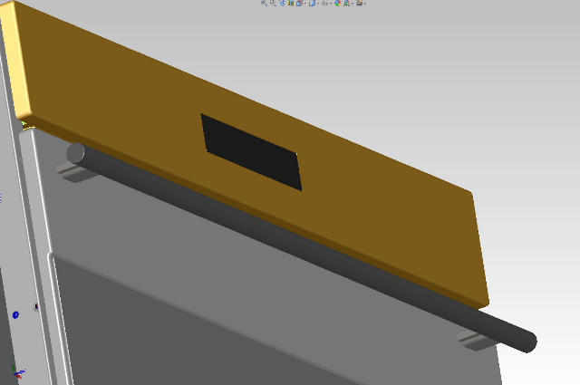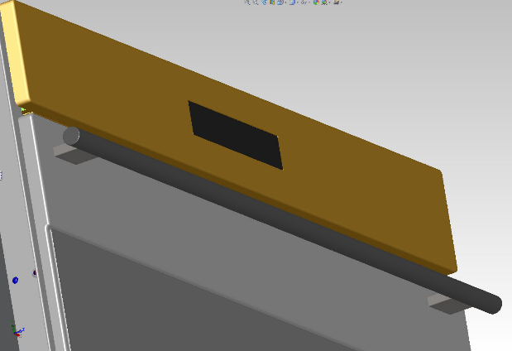

Identifying Product with new standoffs:

The following serial numbers identify the start of production with the new standoffs:
Serial Number Tracking - 30” E Series Contemporary Built-In Oven
- 5610304 - SO30CE/B/TH Starting Serial # 17476645
- 5610305 - DO30CE/B/TH Starting Serial # 17476645
Products with the new standoffs will be identified with a brightly colored corner label (example on next page) to help identify them in your warehouse floor.
Example of Corner Label on Product:
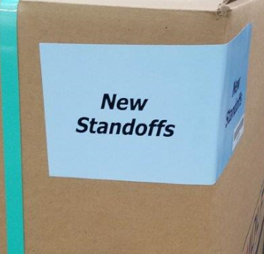
Sales Accessories:

E Series - Warming Drawer Accessory Changes
Old Item Number | New Item Number | Description
822729 | 826747 | (30" E-Series) Contemporary Warming Drawer Front
822731 | 826748 | E Series Contemporary - Warming Drawer Handle Kit

Sales Order Management Systems:

Please update your sales order systems to account for the new item number as needed. Share this number information with your internal organization, and trade partners as you see fit. For those distributors that are on our SOM systems, this change will be managed on your behalf and orders updated to align with the part number change and inventory management.

Be sure to review this information with your sales staff, and other appropriate personnel in your organization. If you have any questions, please contact your regional sales manager or Matt Stieber.

Thank you.

Copy: Regional Sales Managers, Fred Schwartz, Aaron Hotz, Lance Ley, Demand Planning, Mktg Field Communications, Executives and Directors

